Introduction to Programming II project log

Project title: | Coursework – Data Visualisation
Topic: | Week 13 and 14: Research and coding of heat map (population density)
What progress have you made on this topic?
Week 10-12
I added 2 major extensions to my project.

- Waffle Charts – Global Warming Awareness by Age Group.
I sourced survey data online that captured global warming awareness across different age groups. After exploring visualization options, I implemented two side-by-side waffle charts, each representing a different age group. Initially, both charts used the same color scheme, but I refined this by assigning distinct colors to each group. This improved visual contrast and made the comparison more intuitive for viewers.

- Circle Diagrams – UK Food Safety Perceptions (2023 vs 2025)
Using data extracted from an online article, I cleaned and formatted it into CSV for visualization. To compare changes over time, I designed circle diagrams where each category is represented by two concentric circles: the outer circle for 2025 and the inner for 2023. I encountered challenges with label readability, especially when text overflowed. To resolve this, I embedded HTML <div> elements inside the SVG using foreignObject, enabling automatic line wrapping, something native SVG <text> elements don’t support.

Week 13-14
- Heat map for population density of East Asia countries
I sourced population density data from a downloadable CSV and cleaned it to match the scope of my East Asia visualization. I then located an SVG map focused on East Asia and manually found and labelled the path data for each country. After integrating the SVG into my project, I applied heat map coloring principles to reflect density variations. To enhance usability, I implemented zoom and pan controls, along with hover interactions for dynamic feedback.
What problems have you faced and were you able to solve them?
There were several problems I faced when doing this extension.

1.Separating and Combining SVG Paths for East Asia Countries
Problem: The original SVG map file contained an overwhelming number of paths, many of which were grouped or unlabeled. Notably, Korea was represented as a single combined path, making it impossible to manually separate North and South Korea due to the lack of distinct coordinate data. Additionally, countries like Mongolia were visually unified but internally fragmented into many paths with no label, thus unable to identify all paths for Mongolia. (Pic 1)
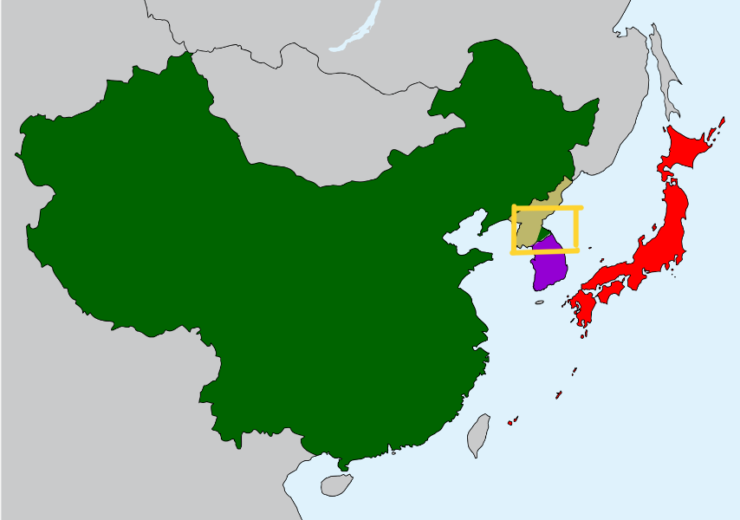
Pic 1: Original SVG map
[Initial attempt to manually separate and combine paths. Inaccurate separation due
to lack of distinct coordinates.]

Solution: To overcome this, I used a canvas-based tool with a smart pencil feature to manually color each East Asia country. (Pic 2) I then exported the result as an SVG file. This allowed me to visually distinguish countries by color and assign id attributes based on those color codes.
However, this process also generated new path data based on the countries I colored, resulting in 456 separate paths for Mongolia alone. To efficiently label these paths, I used Ctrl+F and batch replace to search for each country’s unique fill color and replace it with the corresponding id and full style declaration. (Pic 3)

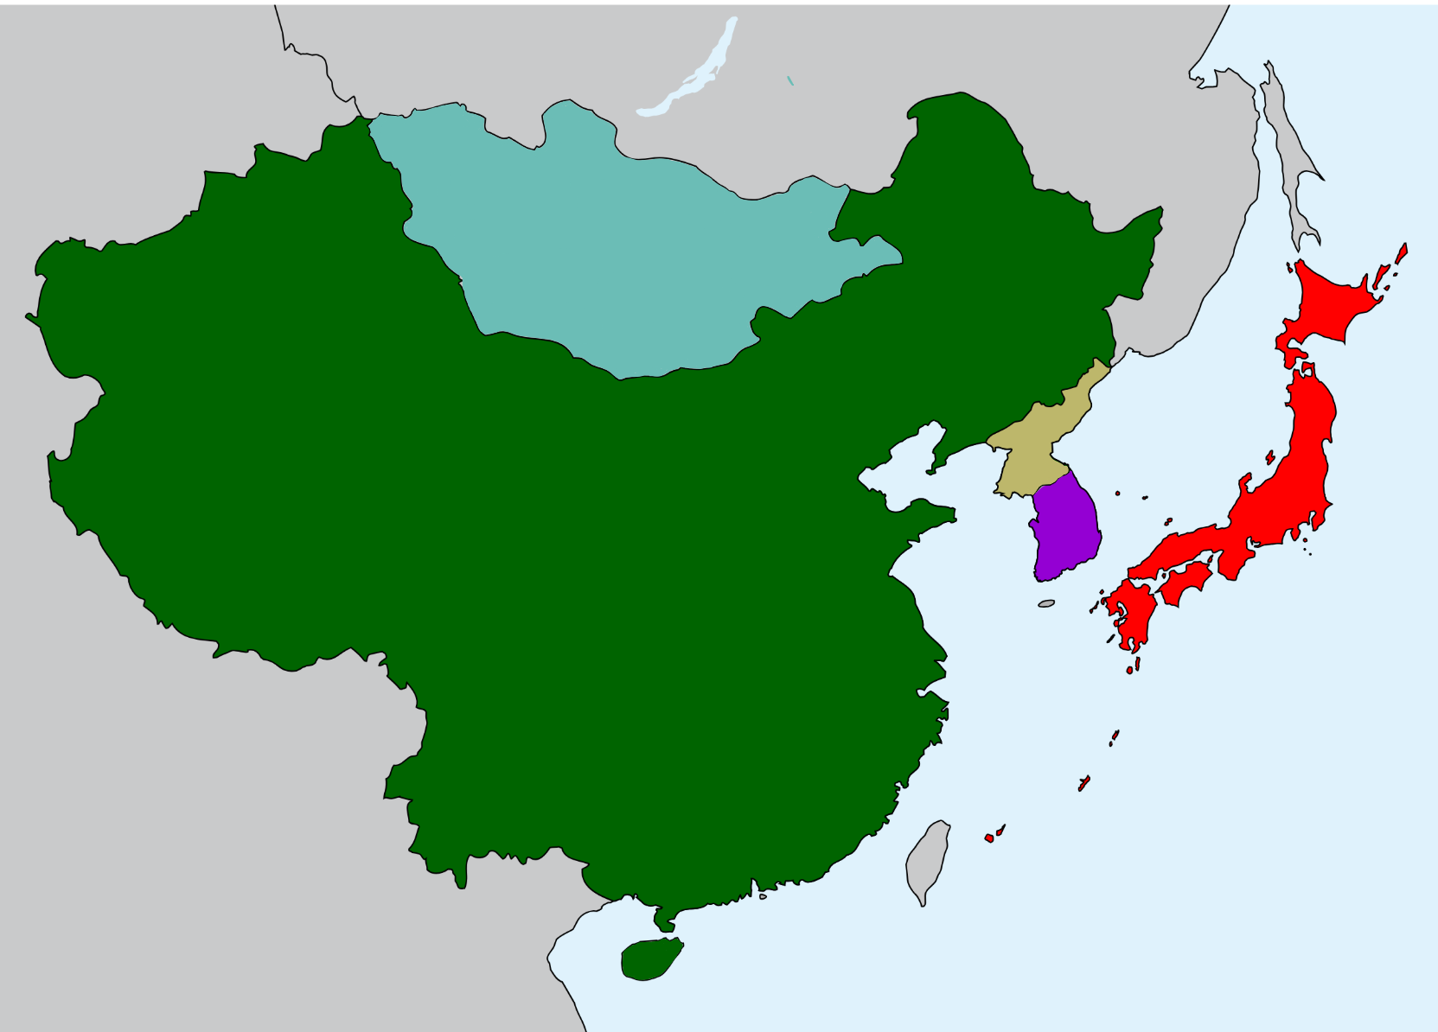
Pic 2: Canvas-Coloured SVG map
[Countries successfully colored, paths can be identified via colour search]
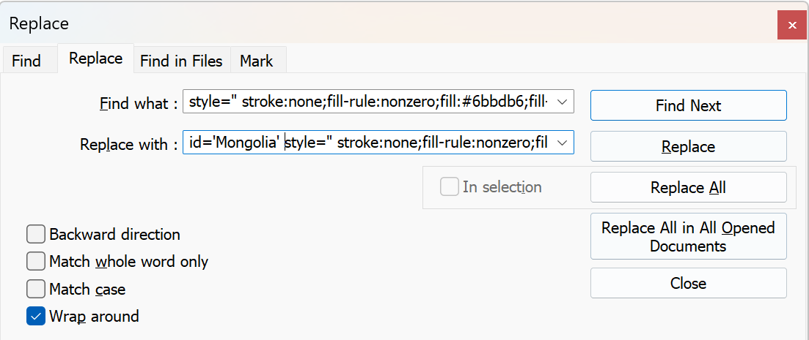
Pic 3: Batch Labeling via Find & Replace

2. Population Density Data not displayed properly.
Problem: The population density data for each country was not displaying correctly in the visualization. When triggered (alert), the value returned was undefined. (Pic 4)

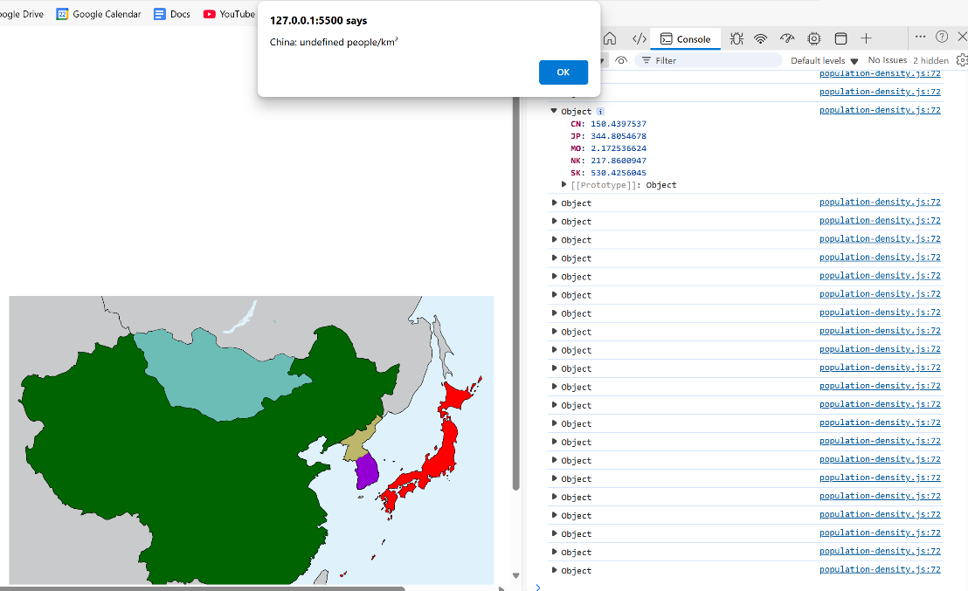
Pic 4: Alert Showing Undefined Data, Console Logs

Solution: I reviewed the console logs and inspected the object structure used to store density values. I realized that the keys in my object were based on country codenames (e.g., "KR") (Pic 4), while the alert logic was referencing full country names (e.g., "South Korea"). This mismatch caused the lookup to fail.
To resolve this, I restructured the object to use country names as keys, aligning it with the identifiers used in the alert and SVG path IDs. (Pic 5) After making this change, the data displayed correctly. (Pic 6)

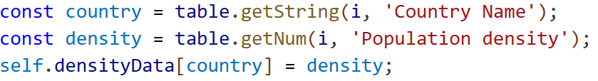
Pic 5: Code – Object Assignment Using Country Names

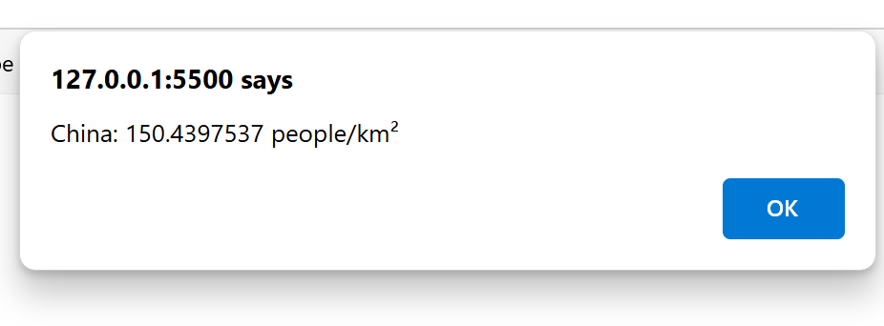
Pic 6: Corrected Alert Output

3. Map Placement and Zoom Behavior Issues
Problem: As shown in Pic 7, the map was misaligned. It was slightly below the menu instead of being beside it, making the interface appear cluttered. I had scaled the map to 60% of its original size, but when the user initiates a zoom or pan, the map would first expand back to its original size. Only after a second interaction would it begin adjusting correctly. Additionally, the map remained visible even when switching to other visualizations. (Pic 8)
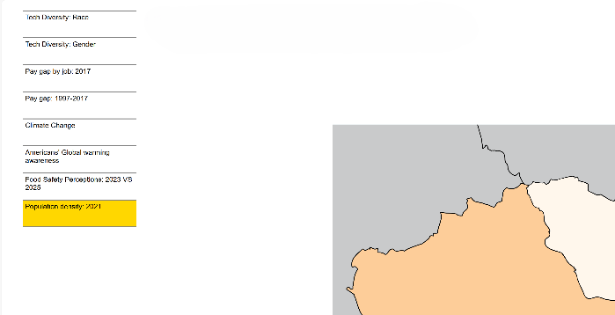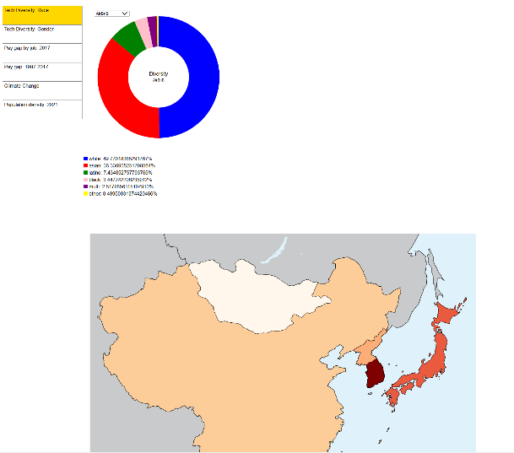
Pic 7: Misaligned Map Placement Pic 8: Zoom Issue

Solution: To resolve this, I defined a fixed transform (initialTransform) with both scale and translation values, and applied it when initializing d3.zoom(). (Pic 9) This ensures that the map loads at the correct size and position, and prevents it from snapping back to full size on first interaction. I also added a destroy function to clean up the map when switching views, which resolved the issue of it lingering across visualizations. (Pic 10)

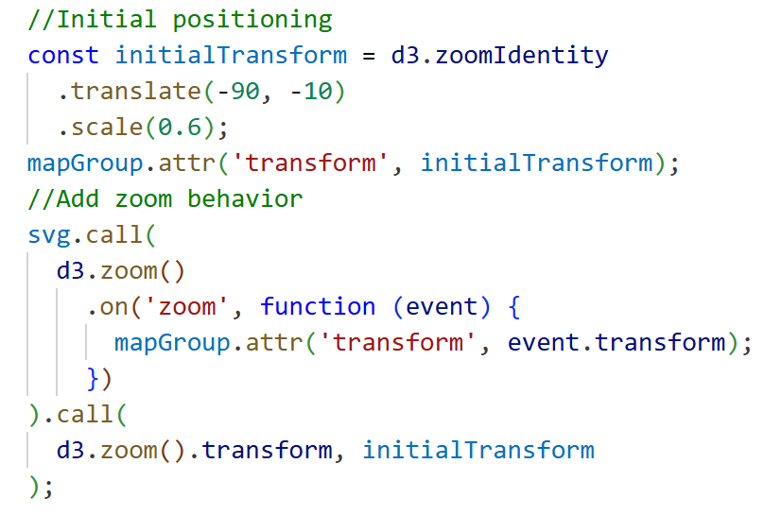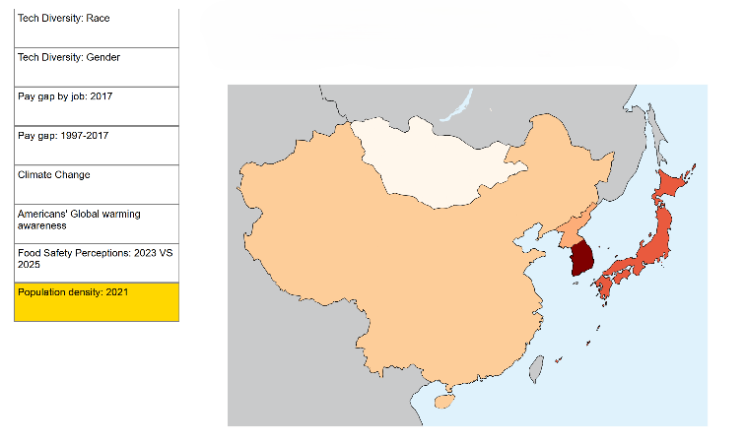
Pic 9: Code – initialTransform setup Pic 10: Final Map Layout with legend space on top
4. Disruptive Data Display Using alert()
Problem: I used alert() to display the country’s population density data when users click on a country. While this worked functionally, it quickly became disruptive, especially when exploring multiple countries, since each alert has to be dismissed manually. This breaks the flow of interaction and creates a frustrating user experience. (Pic 11)

Pic 11: Alert box Displaying Population Density

Solution: I replaced the click-based alerts with a hover interaction. Now, when users hover over a country, its data appears in a display box near the cursor. This approach is smoother and more intuitive, allowing users to explore the map without interruptions.
However, I encountered a positioning issue. The display box appeared far off to the left when hovering over Japan (Pics 12, 14). This was due to relying on relative coordinates affected by SVG transforms. To fix this, I updated the code to use event.pageX and event.pageY (Pic 15), which provide absolute screen coordinates and are unaffected by SVG transformations. This ensures consistent and accurate tooltip placement across all countries. (Pic 13)

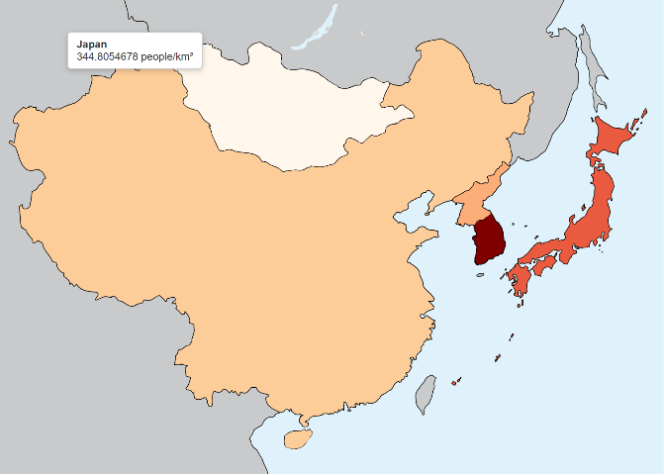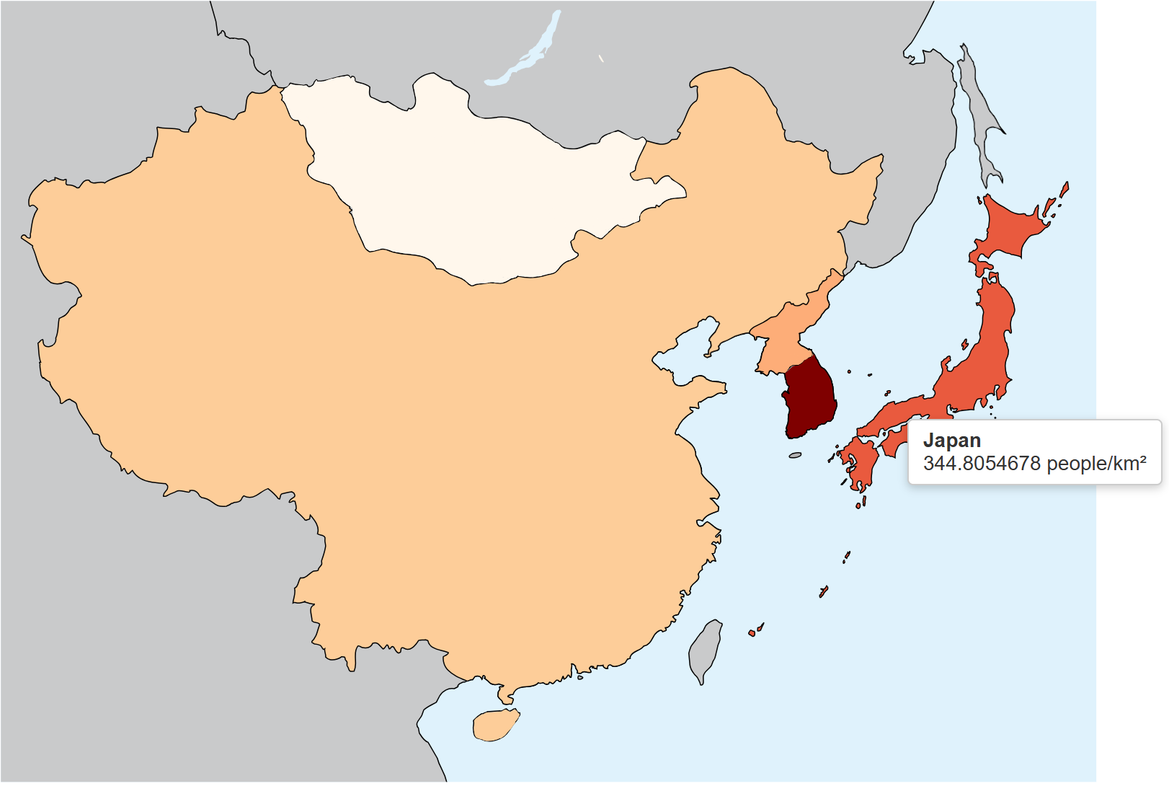
Pic 12: Tooltip Misaligned on Hover Pic 13: Tooltip Correctly Positioned

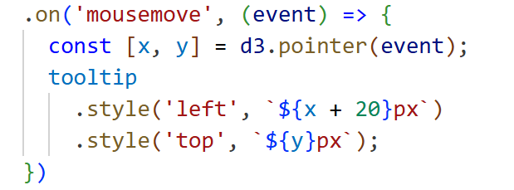 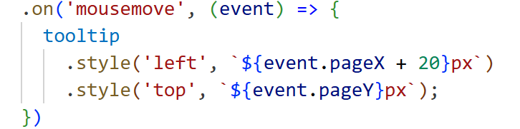Pic 14: Code – Incorrect tooltip positioning Pic 15: Code – Incorrect Tooltip Positioning

What are you planning to do over the next few weeks?
Following the Gantt chart I created earlier, my focus over the next few weeks will be on finalizing the heat map component. This includes:
- Adding a legend to clearly communicate the population density scale and improve interpretability.
- Debugging and feature polishing, with a focus on identifying hidden errors or rendering issues that may affect smooth execution.
- Refining interactions and layout, ensuring that hover effects, zoom/pan controls, and color transitions behave consistently.
This phase will help ensure the visualization is not only technically sound but also user-friendly and visually coherent.

Are you on target to successfully complete your project? If you aren’t on target, how will you address the issue?
I am on target to successfully complete my project. Most of the key extensions, including the waffle chart, circle diagram, and core structure of the heat map, have been implemented. The remaining tasks involve finalising minor components of the heat map and conducting thorough checks.
Throughout development, I’ve performed incremental testing to ensure each extension runs smoothly and that all code behaves as expected. My next steps will focus on comprehensive debugging and final validation to ensure the entire project is stable, visually coherent, and free of critical issues.

